**LEARNING ACTIVITY SHEETS**

**Grade 7 – ELECTRICAL INSTALLATION AND MAINTENANCE**

__________________________________________________________________________________ Name: ____________________ Date: ____________ Rating Score: ____________ **CARRY OUT MEASUREMENTS AND CALCULATIONS**

A. Direction: Find the Greatest Common Factor of the graduation mark in inches as indicated by an arrow and write your answer inside the arrow.

1) 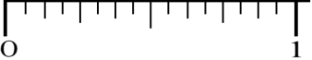 2)  3)  4)  5) 

6) 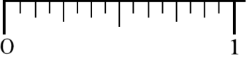

***www.clipartpanda.com***

**__________________________________________________________________________________________ Quarter Week**: _5___

**Target Competency:** TLE_IAE17/8MC 0d-2

**Note to the Teacher**: This material is intended to hone students’ know-how in reading linear measurement. **(This is a Government Property. Not For Sale.)**

**LEARNING ACTIVITY SHEETS**

**Grade 7 – ELECTRICAL INSTALLATION AND MAINTENANCE** __________________________________________________________________________________

B. Direction: Identify the measurement of the graduation mark as indicated by each numbered arrow and write your answer inside the rectangle provided below the ruler.

1

1

1

1

1 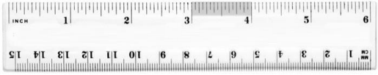

1

1

1

***www.digitallycredible.com***

2 1 1 1 1 1 1 1

3 1 1 1 1 1 1 1

4 1 1 1 1 1 1 1

5

1

1

1

1

1 

1

1

10

11

11

11

1

6 1 1 1 1 1 1 1

7 1 1 1 1 1 1 1

8 1 1 1 1 1 1 1

9 1 1 1 1 1 1 1

1)

2) 3) 4) 5)

6)

7) 8) 9) 10)

C. Direction: Read accurately the measurement of the graduation mark as indicated by each numbered arrow in ***CENTIMETER*** and write your answer inside the rectangle provided below the ruler.

1 1 1 1 1 1 1 1

2 1 1 1 1 1 1 1

3 1 1 1 1 1 1 1

4 1 1 1 1 1 1 1

5 1 1 1 1 1 1 1

6 1 1 1 1 1 1 1

7 1 1 1 1 1 1 1

8 1 1 1 1 1 1 1

9 1 1 1 1 1 1 1

10 11 11 11 1

***room7firth.blogspot.com*** 1)

2) 3) 4) 5)

6) 7)

8) 9) 10)

**__________________________________________________________________________________________ Quarter Week**: _5___

**Target Competency:** TLE_IAE17/8MC 0d-2

**Note to the Teacher**: This material is intended to hone students’ know-how in reading linear measurement. **(This is a Government Property. Not For Sale.)**

**LEARNING ACTIVITY SHEETS**

**Grade 7 – ELECTRICAL INSTALLATION AND MAINTENANCE** __________________________________________________________________________________

D. Read accurately the measurement of the graduation mark as indicated by each numbered arrow in ***MILLIMETER*** and write your answer inside the rectangle provided below the ruler.

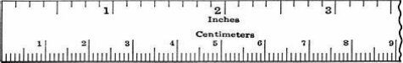***mayroll.blogspot.com***

1 1 1

2 1 1

3 1 1

4 1 1

5 1 1

1) 2) 3) 4) 5) 1

1 1

1 1

1 1

1 1

1

E. Direction: Measure the length of the following materials as per unit indicated and write your

.

answer inside the rectangle. ***www.alibaba.com*** 

***www.alibaba.com***

1

1

1

INCHES

CENTIMETER

1 1 1

1 1 1

1 1 1

1 1 1



***clipart-library.com***

INCHES



***clipart-library.com*** MILLIMETER

**__________________________________________________________________________________________ Quarter Week**: _5___

**Target Competency:** TLE_IAE17/8MC 0d-2

**Note to the Teacher**: This material is intended to hone students’ know-how in reading linear measurement. **(This is a Government Property. Not For Sale.)**