**Technology and Livelihood Education**

**10**

**Quarter 1 - Module 5**

**Lay-out, Mark Pattern**

**and Cut Material**

(Demonstrating lay-outing and marking pattern on material and cutting fabric)

**Dressmaking NC II**

**CO_Q1_TLE 10_Module 5**

10

Technology and Livelihood Education

**Quarter 1 - Module 5**

**Lay-out, Mark Pattern**

**and Cut Material**

(Demonstrating lay-outing and marking pattern on material and cutting fabric)

**Dressmaking NC II**



**Dressmaking – Grade 10**

**Alternative Delivery Mode**

**Quarter 1 – Module 5: Lay-out, Mark Pattern and Cut Material** (Demonstrating lay-outing and marking pattern on material and cutting fabric)

**Republic Act 8293, section 176** states that: No copyright shall subsist in any work of the Government of the Philippines. However, prior approval of the government agency or office wherein the work is created shall be necessary for exploitation of such work for profit. Such agency or office may, among other things, impose as a condition the payment of royalties.

Borrowed materials (i.e., songs, stories, poems, pictures, photos, brand names, trademarks, etc.) included in this module are owned by their respective copyright holders. Every effort has been exerted to locate and seek permission to use these materials from their respective copyright owners. The publisher and authors do not represent nor claim ownership over them.

Published by the Department of Education

Secretary: Leonor Magtolis Briones

Undersecretary: Diosdado M. San Antonio

**Development Team of the Module**

**Writer:** Romana T. Laoyan

**Editors:** Catherine G. Goddi

**Reviewer:** Jonalyn C. Ambrona

Mary Jane N. Malihod

Catherine G. Goddi

**Illustrator:**

**Layout Artist:**

**Management Team:** Estela Leon-Cariño

Carmel F. Meris

Rosita C. Agnasi

Marie Carolyn B. Verano

Christopher C. Benigno

Juliet C. Sannad

Mary Jane N. Malihod

Armi Victoria Fiangaan

Brenda M. Cariño

**Printed in the Philippines by:**

**Department of Education – Cordillera Administrative Region**

Office Address: Wangal, La Trinidad, Benguet

Telefax: (074) -422 -4074

E-mail Address: car@deped.gov.ph

**Introductory Message**

This Self-Learning Module (SLM) is prepared so that you, our dear learners, can continue your studies and learn while at home. Activities, questions, directions, exercises, and discussions are carefully stated for you to understand each lesson.

Each SLMS is composed of different parts. Each part shall guide you step-by-step as you discover and understand the lesson prepared for you.

Pre-tests are provided to measure your prior knowledge on lessons in each SLM. This will tell you if you need to proceed on completing this module or if you need to ask your facilitator or your teacher’s assistance for better understanding of the lesson. At the end of each module, you need to answer the post-test to self-check your learning. Answer keys are provided for each activity and test. We trust that you will be honest in using these.

In addition to the material in the main text, Notes to the Teacher are also provided to our facilitators and parents for strategies and reminders on how they can best help you on your home-based learning.

Please use this module with care. Do not put unnecessary marks on any part of this SLM. Use a separate sheet of paper in answering the exercises and test. And read the instructions carefully before performing each task.

If you have questions in using this SLM or any difficulty in answering the tasks in this module, do not hesitate to consult your teacher or facilitator.

Thank you.

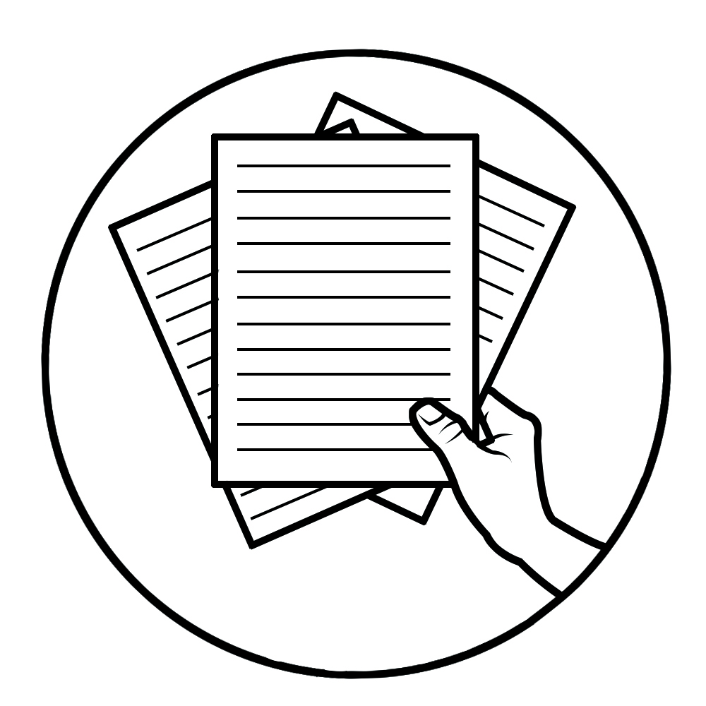

***Notes to the Teacher***

This contains helpful tips or strategies that will help you in guiding the learner.

For the facilitator:

Hi, as a facilitator you are expected to orient the learners on how to use this module. You also need to keep track of the learners' progress while allowing them to manage their own learning. Kindly, advise the learner’s parents or guardians of the same procedure since they will be the primary supporters in the learners’ progress. Please, do not forget to remind the learner to use separate sheets in answering all of the activities found in the learning module

For the learner:

Hello learner, Welcome to the Dressmaking NC II Alternative Delivery Mode (ADM) Module on preparing tools and materials for lay-outing and marking pattern on material. I hope you are ready to progress in your Grade 10 TLE in Dressmaking with this learning module. This is designed to provide you with interactive tasks to further develop the desired learning competencies prescribed in our curriculum. With this, you are expected to appreciate lay-outing and marking pattern on material through the information and activity given.

This module has the following parts and corresponding icons:

|  |  |  |
| --- | --- | --- |
| **ICON** | **LABEL** | **DETAIL** |
|  | What I Need to Know | This contains the learning objectives which you need to accomplish. |
|  | What I know | This evaluates what you know about the lesson you are to learn. |
|  | What’s In | This connects the current lesson with a topic necessary in your understanding. |
|  | What’s New | This introduces the lesson through an activity. |
|  | What Is It | This contains a brief discussion of the learning module lesson. |
|  | What’s More | These are activities to check your understanding of the lesson. |
|  | What I have Learned | This summarizes the important ideas presented in the lesson. |
|  | What I Can Do | This is a real-life application of what you have learned. |
|  | Assessment | This is a post assessment of what you have learned. |
|  | Additional Activity | This is an activity that will strengthen your knowledge about the lesson. |

At the end of this module you will also find:

|  |  |
| --- | --- |
| References | This is a list of all sources used in developing this module. |

**TABLE OF CONTENTS**

What I Need to Know 1

What I Know 2

What’s In 3

What’s New 4

What Is It 6

What’s More 9

What I Have Learned 10

What I Can Do 11

Post-Assessment 12

Additional Activity 14

Answer Key 15

References 16

|  |  |
| --- | --- |
| **Lesson**  **1** | **Lay-outing, marking pattern on material and cutting for ladies skirt** |

The following are some reminders in using this module:

1. Use the module with care. Do not put unnecessary mark/s on any part of the module. Use a separate sheet of paper in answering the exercises.
2. Don’t forget to answer *What I Know* before moving on to the other activities included in the module.
3. Read the instruction carefully before doing each task.
4. Observe honesty and integrity in doing the tasks and checking your answers.
5. Finish the task at hand before proceeding to the next.
6. Return this module to your teacher/facilitator once you are through with it.

If you encounter any difficulty in answering the tasks in this module, do not hesitate to consult your teacher or facilitator. Always bear in mind that you are not alone.

We hope that through this material, you will experience meaningful learning and gain deep understanding of the relevant competencies. You can do it!

# C:\Users\DEPED\Desktop\ADM specs\ADM cover and icons\ADM Icons\Alamin2.jpg

# What I Need to Know

This module was designed and written to guide you to acquire the learning competencies and develop your skills in lay-outing, marking pattern and cutting on material for ladies skirt in dressmaking. The scope of this module permits it to be used in many different learning situations. The language used recognizes the diverse vocabulary level of students. The lessons are arranged to follow the standard sequence of the course. However, the order in which you read the module can be changed to correspond with the textbook you are now using.

|  |  |
| --- | --- |
| Quarter/Week | Q1/W5 |
| Learning Competency Code | TLE_HEDM9-12SK-Id -2 |
| Learning Competency | **LO 2**. Prepare and cut materials for  ladies skirt |
|  | **2.2** Lay-out and mark pattern on  material |

**2.3** Cut materials

**Learning Objectives:**

After going through this module, you are expected to:

1. identify the layout fold of the material in lay-outing pattern for ladies

skirt;

2. follow the correct lay-outing, cutting and marking pattern on material

for ladies’ skirt;

3. demonstrate the correct lay-outing and marking pattern on the material

for ladies’ skirt; and,

4. develop resourcefulness, creativity, independence and passion towards

learning



# What I Know

**Pretest**

**Multiple Choice.**

**ACTIVITY 1: Directions:** Choose the letter of the best answer.

Write the chosen letter on the answer sheet provided.

_____1. Liza wants to transfer pattern marks on the fabric, what marking tool will she use?

A. Tailor’s chalk B. Tracing wheel

C. Carbon paper D. Ballpen

_____2. It is a dressmaker’s guide in cutting fabric pieces in accordance with

the garment design.

A. Dressmaker scale B. Pattern

C. Manuscript D. Design

_____3. The arrangement of pattern pieces on the fabric is called?

A. marking B. cutting

C. lay-outing D. stitching

_____4. It is a process of transferring necessary lines from pattern pieces to

the fabric.

A. marking B. cutting

C. lay-outing D. stitching

_____5. What part of pattern pieces should be lay -out first on the fabric?

A. Large part B. Small part

C. All large part D. All small part

_____6.  The pattern pieces are usually place on the _________ of fabric.

A. Right side B. Both sides

C. Wrong side D. Crosswise

____7. Which of the following is to determine the right side of the material?

A. The fabric center fold B. The fabric print

C. The fabric texture D. A, B, C

____8. It is a strand of thread along the selvage.

A. Crosswise grain B. Lengthwise grain

C. Bias grain D. A and B

____9. It is called a fabric fold on lengthwise grain, right sides together, only

wide enough to fit the widest pattern pieces.

A. Partial fold B. Crosswise fold

C. Double fold D. Lengthwise fold

____10. What do we called the threads that runs from one selvage to the

other selvage.

A. Lengthwise grain B. True bias grain

C. Crosswise grain D. Bias grain

____11. Which is the thread line that is at forty-five-degree angle of the

fabric?

A. Lengthwise grain B. True bias grain

C. Crosswise grain D. Bias grain

____12. Which fold of fabric is half lengthwise with right side together?

A. Lengthwise fold B. Partial fold

C. Crosswise fold D. Double fold

____13. What do we called the marking tools use to transfer mark on the

fabric with the used of dressmaker`s paper?

A. Tailor chalk B. Tracing wheel

C. Tailor pencil D. Pencil

____14. Why is it necessary to trace a mark line of pattern pieces on the

fabric?

A. The mark line is the guide for stitching

B. The mark line is the guide for cutting

C. The mark line is the guide for Trimming

D. The mark line is the guide for edging

____15 .Which of the following fabric folds are fold twice along the lengthwise

grain, right sides together?

A. Lengthwise fold B. Double fold

C. Crosswise fold D. Partial fold

# C:\Users\DEPED\Desktop\ADM specs\ADM cover and icons\ADM Icons\Balikan.jpg

# What’s In

# In laying out pattern, the pattern pieces are always placed on the lengthwise grain to have a good outcome of the finished garment and wrong side of the fabric so that it will be easier to transfer markings. This also help to protect your fabric from soil or dirt . And now we are going to learn the following in this lesson.

**ACTIVITY 2**: Identify the pattern symbols by selecting the correct answer below. Write your answer in the answer sheet.

Cutting line Pattern adjustment line Fold line

Stitching line Crosswise grain Lengthwise grain

Bias Notches Centerfold

Dart

1. __________________ 1.________________________

2. V V V V V V 2. ________________________

3. 3._________________________

4. 4._________________________

5. -- - - - - - - - - - - - - - 5. ________________________

6. 6. ________________________

7. ___ ____ ___ ____ 7. _________________________

8. 8. _________________________

9. O  9._________________________

O O

10. 10. ____________________

# C:\Users\DEPED\Desktop\ADM specs\ADM cover and icons\ADM Icons\Tuklasin.jpg What’s New

**Picture Reading**

**ACTIVITY 3: Picture reading**: Observe the images below and identify the

fabric folding for lay-outing. Write your answer in the provided

answer sheet.

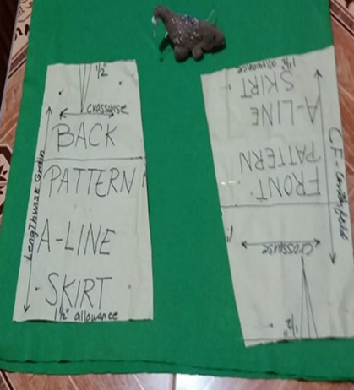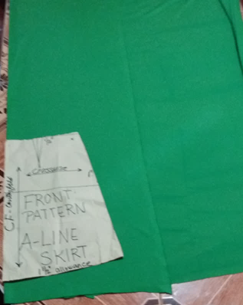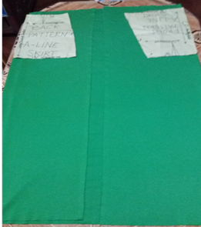

**3**

**2**

**1**

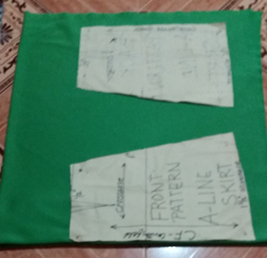

**4**

1._____________

2._____________

3._____________

4._____________

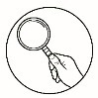 ***What Is It***

# THE PATTERN LAYOUT

Locate and circle the cutting layout for your particular view, size, and fabric width. Be sure to use the “with nap” layout if the fabric has a nap, pile, shading or a one-way design. The cutting guide will show you exactly how to layout the pattern pieces so that all pieces will fit on the minimum amount of fabric. The pattern pieces are placed on the wrong side of the fabric.

**Patterns** are devices used by dressmaker as a guide in cutting certain

kind of garment or article.

**Lay-out** is the arrangement of pattern pieces on a fabric.

**Marking** is done by indicating and transferring lines on the fabric tracing

the pattern pieces.

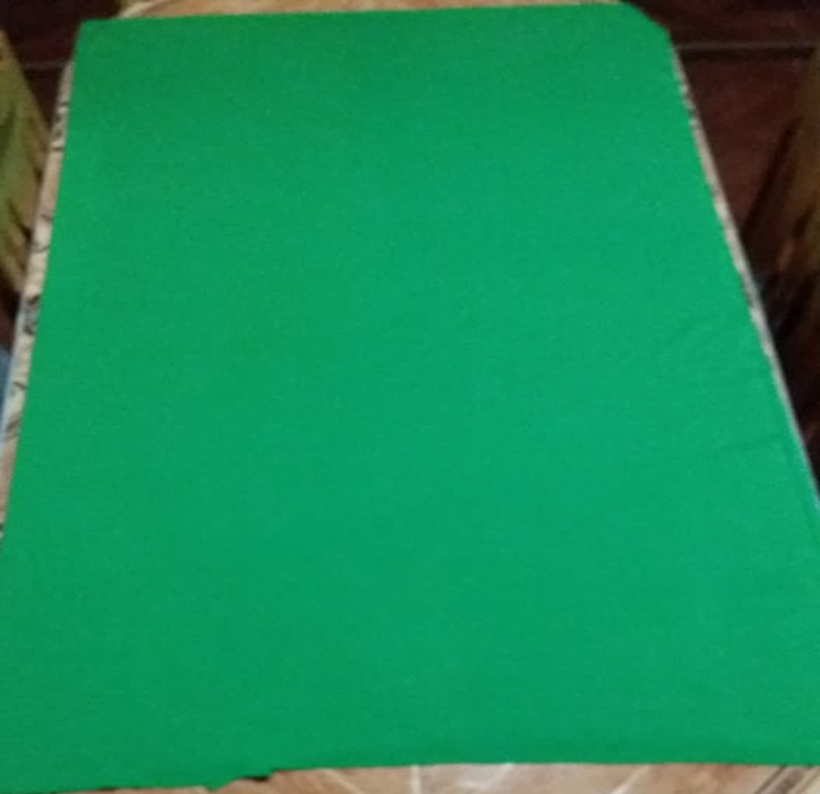

**LENGTWISE GRAIN**

**SELVAGE**

**CROSSWISE GRAIN**

**CENTER FOLD**

**Folding the fabric**

**1. Lengthwise fold** – fabric fold in half lengthwise with right side

together. Match the selvage and ends.

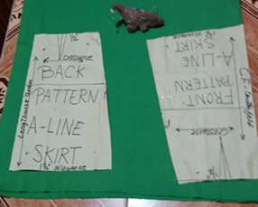

**2. Crosswise fold** – fabric fold in crosswise with right sides together. Match

the raw edge and keep the two layers of selvage even along each side.

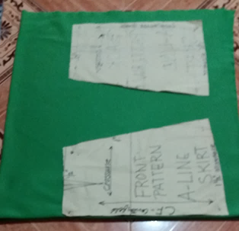

**CROSSWISE GRAIN**



**LENGTHWISE GRAIN**

**3.Double fold**- fold fabric twice along the lengthwise grain, right sides

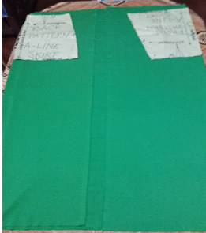 together.

**4. Partial fold** – fabric fold on lengthwise grain, right sides together, only

wide enough to fit the widest pattern pieces.

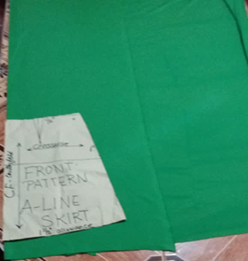

|  |
| --- |
|  |

**PATTERN LAY-OUTING**

Laying out pattern pieces on the fabric is a step to set the fabric for cutting and marking and this is important step that must be done carefully and accurately for great-looking results.

1. Plan the work to be done.

2. Prepare all the pattern pieces.

3. Fold the fabric facing right side together, then the wrong side on top of

the cutting table.

4. Lay- out all patterns in the same position following the lengthwise

grain.

5. Pattern pieces should be placed exactly on the proper grain line.

6. Never try to tilt or angle any pattern pieces.

7. Lay- out the large pattern pieces and pin.

8. Double- check the lay-outing, the position and grain line straight.

9. Lay-out front pattern center fold and 1 ½ inch from the selvage for the

back pattern, if it is zipper at back, but if side zipper, front and back

pattern should be both center fold.

**CUTTING HINTS**

1. Plan the work to be done. Measure twice cut once

2. Check the pins to be sure that they are not over the cutting line.

3. Move around the table while cutting the fabric.

4. Use long stroke cutting on the straight line and short stroke cutting on

the curve line.

5. Hold the fabric flat with your left hand and cut it with your right hand.

6. Never lift or move the fabric while cutting.

7. Do not extend cutting on the marking line.

8. Cut all notched pointing out.

9. Cut closely as possible to the edge of the pattern pieces so that your

fabric will be exact size of the pattern

10. Use sharp shear the size of which is suitable to the weight of the

fabric.

**MARKING**

The lines and symbols marked along the edges and inside the pattern pieces will help you to assemble your garment. These markings should be transferred to your fabric before the pattern is unpinned. The markings must be visible as you sew, but they should never show on the ouside of your finished garment .

**Marking with tracing wheel**

1. Mark all the construction lines such as dart and seamlines.
2. Transfer the mark to the other wrong side of fabric with the use of tracing wheel and dressmaker`s tracing paper or tailor chalk .
3. Choose a color of tracing paper that is similar to your fabric color, or used carbon paper .
4. Test on a scrap of fabric to be sure that the markings do not show through on the right side.
5. Use caution with light-colored and light weight fabric.
6. Place waxy side of paper against the wrong side of the fabric .
7. Mark all symbols by pressing down lightly on the tracing wheel .
8. Guide the tracing wheel over each line or mark only once .

**Marking with tailor chalk**

1. Mark only the wrong side of the fabric with either a flat square of chalk or chalk pencil.
2. Be sure that the edge or point is sharp so that the markings are accurate.
3. Push a pin through both layers of fabric at each symbols to be mark .
4. Carefully losen the pattern paper and slip it over the pin .
5. Make a chalk dot at each pin on the layer of fabric .
6. Turn fabric over and mark other layer at each pin.

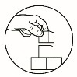

# What’s More

**ACTIVITY 4: Truth or Bluff**: Write letter **T** if the statement is correct and **B** if the statement is wrong. Write your answer on the answer sheet.

______1. Transfer the mark on right side of fabric.

______2. All markings should be done on the wrong sides of the fabric.

______3. Layout is a guide of a dressmaker in cutting a garment.

______4. Fold the fabric wrong side together

______5. Pattern pieces should be place in proper grain lines of fabric.

______6. Lay out the large part of pattern pieces and pin.

______7. Pattern pieces should be layout in an angle on fabric.

______8. Lift or move the fabric while cutting.

______9. Cut the fabric with your right hand and hold it flat with your left

hand.

______10. Marking using tracing wheel and dressmaker`s paper done once.

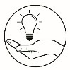

# What I What I Have Learned

**ACTIVITY 5: Fill in the blank**: Analyze the statement and complete the

words by filling up the missing letter. Write your

answer on the answer sheet.

1. This is the process of applying **l_y_u_t_n_** where patterns pieces are arrange on fabric
2. The interlacing of fiber together to produce **f_ _ric**.
3. The **_at_er_** is a guide of a **dr_s_ma_e**_ in cutting a garment.
4. It is done by indicating and transferring lines from pattern to fabric is called **m_r_i_g.**
5. The **l_ng_ _w_s_** runs in the same direction or it runs along the selvage
6. The finished lengthwise edge of the fabric is **_e_l_ag**_.
7. The **c_ _ss_ _se** grain that runs across the fabric from the one selvage to the other selvage .
8. It is a fold on the other end or opposite of the selvage is **c_ n_ _rf_ld**.
9. Mark the stitching line on the wrong side of the m**_t_ri_al**.
10. ____________________
11. ____________________
12. ____________________
13. ____________________
14. ____________________
15. ____________________
16. ____________________
17. ____________________
18. ____________________

10. ____________________

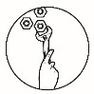

# What I What I Can Do

**ACTIVITY 6:** Demonstrate the correct lay-outing, marking and

cutting on material with seam allowances. Follow the

procedure in making your project.

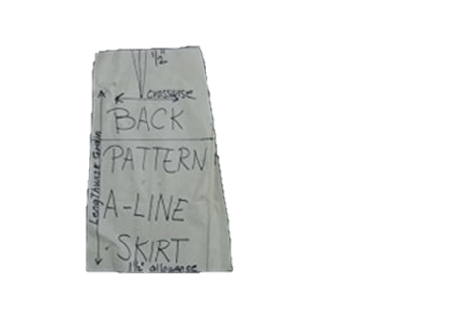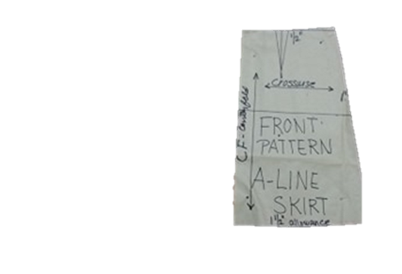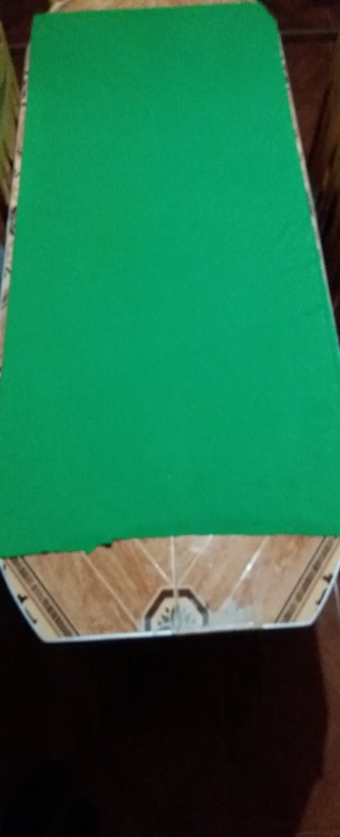

**SELVAGE**

**CROSSWISE GRAIN**

**Pattern**

**Fabric**

**LENGTHWISE GRAIN**

**CENTER FOLD**

**RUBRICS IN EVALUATING LAY-OUTING PATTERN PIECES,**

**MARKING AND CUTTING FABRIC FOR LADIES SKIRT**

|  |  |  |  |  |
| --- | --- | --- | --- | --- |
| **ITEMS** | **20** | **15** | **10** | **Score** |
| Lay-outing process | All steps in lay-outing pattern were followed correctly | Most of the steps in lay-outing pattern were followed correctly | Some of the steps in lay-outing pattern were followed correctly |  |
| Cutting process | All steps in cutting fabric were followed correctly | Most of the steps in cutting fabric were followed correctly | Some of the steps in cutting fabric were followed correctly |  |
| Construction markings | All steps in markings fabric were followed correctly | Most of the steps in markings fabric were followed correctly | Some of the steps in markings fabric were followed correctly |  |
| **TOTAL** | | | |  |

# C:\Users\DEPED\Desktop\ADM specs\ADM cover and icons\ADM Icons\Tayahin.jpg Post-Assessment

**Multiple Choice**

**ACTIVITY 7:**

**Directions:** Choose the letter of the best answer.

Write the chosen letter on the answer sheet.

_____1. The pattern pieces are usually place on ____________ fabric.

a. Right side b. Both sides

c. Wrong side d. Crosswise

_____2. Which of the following indication is to determine the right side of the

material?

a. The fabric fold b. The fabric print

c. The fabric texture d. A, B, C

_____3. It is a strand of thread along the selvage.

a. Crosswise grain b. Lengthwise grain

c. Bias grain d. A and B

_____ 4. The fabric fold on lengthwise grain, right sides together, only

wide enough to fit the widest pattern pieces.

a. Partial fold b. Crosswise fold

c. Double fold d. Lengthwise fold

_____ 5. It is the thread that runs from one selvage to the other selvage.

a. Lengthwise grain b. True bias grain

c. Crosswise grain d. Bias grain

_____ 6. Liza wants to transfer pattern marks on the fabric, what marking

tool will she use?

a. Tailor’s chalk c. Pen

b. Carbon paper d. Ball pen

______7. A dressmaker’s guide in cutting fabric pieces in accordance with

the garment design.

a. Dressmaker scale c. Pattern

b. Manuscript d. Design

_____8. The arrangement of pattern pieces on the fabric is called

a. marking b. cutting

c. lay-outing d. stitching

_____9. It is a process of transferring necessary lines from pattern to fabric.

a. marking b. cutting

c. lay-outing d. stitching

_____10. What part of pattern pieces should be lay-out first on the fabric?

a. Large part b. Small part

c. All large part d. All small part

____11. What do we call the marking tools use to transfer marks on the

fabric with the used of dressmaker`s paper?

a. Tailor chalk b. tracing wheel

c. Tailor pencil d. Pencil

____12. Why is it necessary to trace a mark line of pattern pieces on fabric?

a. The mark line is the guide for stitching

b. The mark line is the guide for cutting

c. The mark line is the guide for Trimming

d. The mark line is the guide for edgings

____13.Which fold of fabric is fold twice along the lengthwise grain, right

sides together?

A. Lengthwise fold B. Double fold

C. Crosswise fold D. Partial fold

____14. Which is the thread line that is at forty five degree angle of the

fabric?

A. Lengthwise grain B. True bias grain

C. Crosswise grain D. Bias grain

____15. It is a fold of fabric in half lengthwise with right side together.

A. Lengthwise fold B. Partial fold

C. Crosswise fold D. Double fold

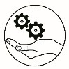

***Additional Activity***

**ACTIVITY 8:** WORD SEARCH PUZZLE. Find the 20 words in the

puzzle. Write your answer in the answer sheet.

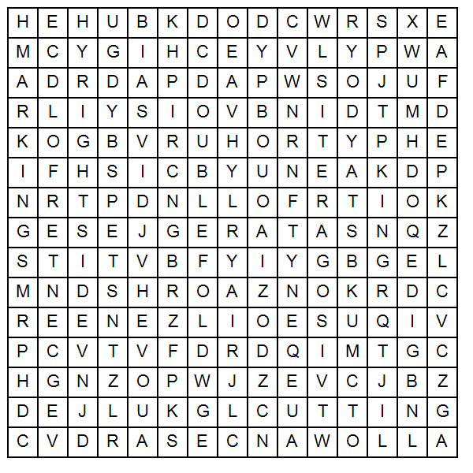

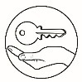

# Answer Key

**What I Know** **What`s In** **What’s New**  **What’s More**

**What I Have Learned** **What I Can Do**  **Assessment**

**Additional Activity**

1.cutting line

2.notch

3.pattern adjustment line

4.dart

5.stitching line

6.bias

7.fold line

8.crosswise

9.center fold

10.lengthwise

1.patial fold

2. double fold

3.lengthwise fold

4. crosswise fold

1.b

2.b

3.c

4.a

5.a

6.a

7.d

8.b

9.a

10.c

11.b

12.c

13.b

14.a

15.b

1. F

2. T

3. F

4. F

5. T

6. T

7. T

8. F

9. T

10.T

Performance output will be evaluated through given rubrics

1.lengthwise fold

2.crosswise fold

3.markings

4.layout

5.cutting

6.steps

7.fabric

8.cloth

9.centerfold

10.centerfront

11.centerback

12.bias

13.wrongside

14.right side

15.partial fold

16.double fold

17.pattern paper

18.allowance

19.construction marking

20.stitching line

1.layouting

2.fabric

3.pattern

4.dressmaker

5.marking

6.lengthwise

7.selvage

8.crosswise

9.centerfold

10.material

1.c

2.d

3.b

4.a

5.c

6.a

7.c

8.c

9.a

10.a

11.b

12.a

13.b

14.b

15.a

# References

Lewis, Dora. Clothing construction and Wardrobe planning.

New York: McMillan Publishing Company, 1955

www.pinterst.com.aidala.clothing-referencewww.

www.pinterest.com.therealem.fashion.

Armstrong, HJ 1986, Pattern Making for fashion Design. Harper and Row, New York

Home Technology Clothing I and II

Photos owned by module developer

**For inquiries or feedback, please write or call:**

Department of Education - Bureau of Learning Resources (DepEd-BLR)

Ground Floor, Bonifacio Bldg., DepEd Complex

Meralco Avenue, Pasig City, Philippines 1600

Telefax: (632) 8634-1072; 8634-1054; 8631-4985

Email Address: blr.lrqad@deped.gov.ph * blr.lrpd@deped.gov.ph

Telefax: (632) 8634-1072; 8634-1054; 8631-4985

Email Address: blr.lrqad@deped.gov.ph * blr.lrpd@deped.gov.ph