**Technology and Livelihood Education**

**10**

**Quarter 1 - Module 6**

**Prepare Cut Parts, Assemble and**

**Sew Ladies Skirt**

**Dressmaking NC II**

**CO_Q1_TLE 10_Module 6**

10

Technology and Livelihood Education

**Quarter 1 - Module 6**

**Prepare Cut Parts, Assemble and**

**Sew Ladies Skirt**

**Dressmaking NC II**



**Dressmaking – Grade 10**

**Alternative Delivery Mode**

**Quarter 1 – Module 6: Prepare cut parts and assemble, sew ladies skirt**

**Republic Act 8293, section 176** states that: No copyright shall subsist in any work of the Government of the Philippines. However, prior approval of the government agency or office wherein the work is created shall be necessary for exploitation of such work for profit. Such agency or office may, among other things, impose as a condition the payment of royalties.

Borrowed materials (i.e., songs, stories, poems, pictures, photos, brand names, trademarks, etc.) included in this module are owned by their respective copyright holders. Every effort has been exerted to locate and seek permission to use these materials from their respective copyright owners. The publisher and authors do not represent nor claim ownership over them.

Published by the Department of Education

Secretary: Leonor Magtolis Briones

Undersecretary: Diosdado M. San Antonio

**Development Team of the Module**

**Writer:** Romana T. Laoyan

**Editors:** Catherine G. Goddi

**Reviewer:** Jonalyn C. Ambrona

Mary Jane N. Malihod

Catherine G. Goddi

**Illustrator:**

**Layout Artist:**

**Management Team:** Estela Leon-Cariño

Carmel F. Meris

Rosita C. Agnasi

Marie Carolyn B. Verano

Christopher C. Benigno

Juliet C. Sannad

Mary Jane N. Malihod

Armi Victoria Fiangaan

Brenda M. Cariño

**Printed in the Philippines by:**

**Department of Education – Cordillera Administrative Region**

Office Address: Wangal, La Trinidad, Benguet

Telefax: (074) -422 -4074

E-mail Address: car@deped.gov.ph

**Introductory Message**

This Self-Learning Module (SLM) is prepared so that you, our dear learners, can continue your studies and learn while at home. Activities, questions, directions, exercises, and discussions are carefully stated for you to understand each lesson.

Each SLMS is composed of different parts. Each part shall guide you step-by-step as you discover and understand the lesson prepared for you.

Pre-tests are provided to measure your prior knowledge on lessons in each SLM. This will tell you if you need to proceed on completing this module or if you need to ask your facilitator or your teacher’s assistance for better understanding of the lesson. At the end of each module, you need to answer the post-test to self-check your learning. Answer keys are provided for each activity and test. We trust that you will be honest in using these.

In addition to the material in the main text, Notes to the Teacher are also provided to our facilitators and parents for strategies and reminders on how they can best help you on your home-based learning.

Please use this module with care. Do not put unnecessary marks on any part of this SLM. Use a separate sheet of paper in answering the exercises and test. And read the instructions carefully before performing each task.

If you have questions in using this SLM or any difficulty in answering the tasks in this module, do not hesitate to consult your teacher or facilitator.

Thank you.

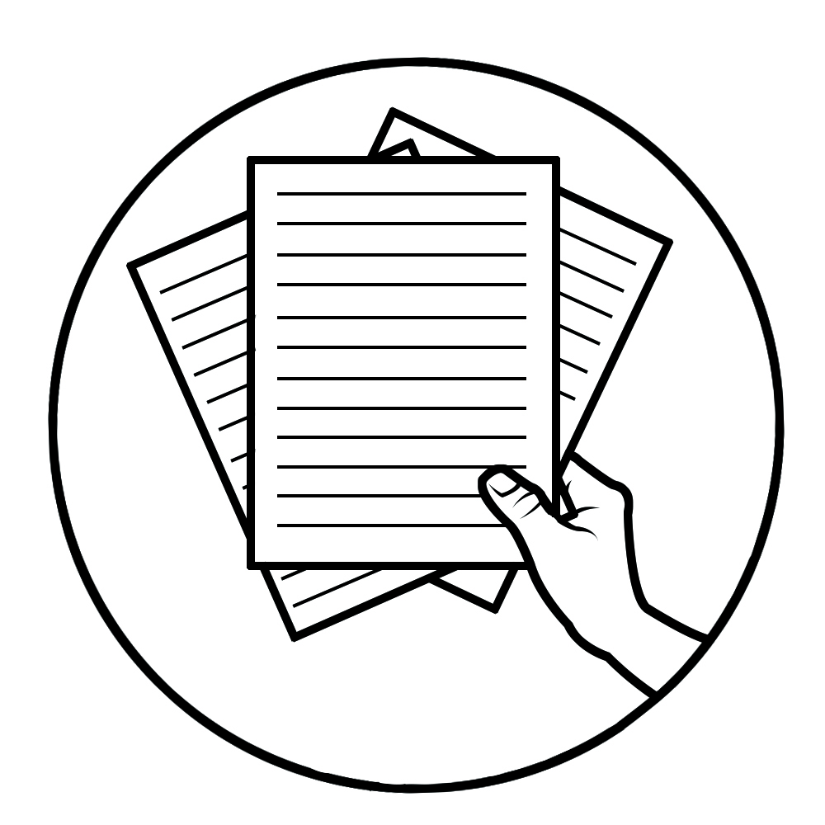

***Notes to the Teacher***

This contains helpful tips or strategies that will help you in guiding the learner.

For the facilitator:

Hi, as a facilitator you are expected to orient the learners on how to use this module. You also need to keep track of the learners' progress while allowing them to manage their own learning. Kindly, advise the learner’s parents or guardians of the same procedure since they will be the primary supporters in the learners’ progress. Please, do not forget to remind the learner to use separate sheets in answering all of the activities found in the learning module.

For the learner:

Hello learner, Welcome to the dressmaking NC II Alternative Delivery Mode (ADM) Module on preparing cut parts, assembling and sewing ladies skirt. I hope you are ready to progress in your Grade 10 TLE in Dressmaking with this learning module. This is designed to provide you with interactive tasks to further develop the desired learning competencies prescribed in our curriculum. With this, you are expected to appreciate sewing through the information and activity given.

This module has the following parts and corresponding icons:

|  |  |  |
| --- | --- | --- |
| **ICON** | **LABEL** | **DETAIL** |
|  | What I Need to Know | This contains the learning objectives which you need to accomplish. |
|  | What I know | This evaluates what you know about the lesson you are to learn. |
|  | What’s In | This connects the current lesson with a topic necessary in your understanding. |
|  | What’s New | This introduces the lesson through an activity. |
|  | What Is It | This contains a brief discussion of the learning module lesson. |
|  | What’s More | These are activities to check your understanding of the lesson. |
|  | What I Have Learned | This summarizes the important ideas presented in the lesson. |
|  | What I Can Do | This is a real-life application of what you have learned. |
|  | Assessment | This is a post assessment of what you have learned. |
|  | Additional Activity | This is an activity that will strengthen your knowledge about the lesson. |

At the end of this module you will also find:

|  |  |
| --- | --- |
| References | This is a list of all sources used in developing this module. |

**TABLE OF CONTENTS**

What I Need to Know 1

What I Know 2

What’s In 4

What’s New 4

What Is It 6

What’s More 10

What I What I Have Learned 10

What I Can Do 12

Post-Assessment 14

Additional Activity 15

Answer Key 16

References 17

|  |  |
| --- | --- |
| **Lesson**  **6** | **Preparing cut parts in assembling and sewing ladies skirt** |

The following are some reminders in using this module:

1. Use the module with care. Do not put unnecessary mark/s on any part of the module. Use a separate sheet of paper in answering the exercises.
2. Don’t forget to answer *What I Know* before moving on to the other activities included in the module.
3. Read the instruction carefully before doing each task.
4. Observe honesty and integrity in doing the tasks and checking your answers.
5. Finish the task at hand before proceeding to the next.
6. Return this module to your teacher/facilitator once you are through with it.

If you encounter any difficulty in answering the tasks in this module, do not hesitate to consult your teacher or facilitator. Always bear in mind that you are not alone.

We hope that through this material, you will experience meaningful learning and gain deep understanding of the relevant competencies. You can do it!

# C:\Users\DEPED\Desktop\ADM specs\ADM cover and icons\ADM Icons\Alamin2.jpg

# What I Need to Know

This module was designed and written to guide you to acquire the learning competencies and develop your skills in assembling and sewing ladies skirt in Dressmaking. The scope of this module permits it to be used in many different learning situations. The language used recognizes the diverse vocabulary level of students. The lessons are arranged to follow the standard sequence of the course. However, the order in which you read the module can be changed to correspond with the textbook you are now using.

|  |  |
| --- | --- |
| Quarter/Week | Q1/W6 |
| Learning Competency Code | TLE_HEDM9-12SK-Ie -1-3 |
| Learning Competency | **LO 3.** Assemble garment parts for  Ladies skirt  3.1 Prepare cut parts |

3.2 Assemble and sew ladies skirt

**Learning Objectives:**

After going through this module, you are expected to:

1. identify the cut parts for assembling and sewing ladies skirt;
2. follow the steps in assembling and sewing ladies skirt;
3. perform the correct steps in assembling and sewing ladies skirt; and,
4. develop traits such as ingenuity, resourcefulness, creativity, independence and passion towards learning.



# What I Know

**ACTIVITY 1**

**Pretest**

**Directions:** Multiple Choice.Choose the letter of the best

answer.Write the chosen letter on the answer sheet

provided.

_____1. This is a part of ladies skirt which is attached to the waistline.

A. Zipper B. Dart

C. Waistband D. Pocket

_____2. It is a fastener appropriate for ladies skirt placket.

A. Button B. Hook and eye

C. Zipper D. Snap

_____3. It is a combination of machine and hand stitching in garment

construction.

A. Assembling B. Preparing

C. Sewing D. Stitching

_____4. This is used to combine two pieces of fabric together, by pinning and

basting for garment.

A. Prepare B. Assemble

C. Stitch D. Sew

_____5. The temporary stitch made by hand before final sewing is done.

A. Sew B. Stitch

C. Baste D. Assemble

_____6. These are the joining of two or more pieces of fabric to form a

garment.

A. Seam B. Slash

C. Hem D. Trim

_____7. This is a method which is to cut through the center fold of dart,

curve line and center seam.

A. Slash B. Baste

C. Trim D. Cut

_____8. This is a method which is to cut ragged edges, ravelled thread or

part of seam allowance.

A. Slash B. Baste

C. Trim D. Cut

_____9. This is used to provide opening of a garment for ease in putting on

and putting off.

A. Placket B. Waistband

C. Fastener D. Seams

_____10. It is a strip of fabric encircling the waistline at the top of a skirt or

pants.

A. Placket B. Waistband

C. Fastener D. Seams

_____11. What is the usual length of the zipper use for A-line skirt with

zipper at back?

A. 16 inches long B. 12 inches long

C. 8 inches long D. 3 inches long

_____12. The standard width of a finished waistband for ladies skirt is ___ ?.

A. ½ inch B. ¼ inch

C. 1 ½ inch D. ¾ in

_____13.The position of the finished zipper at the back part of skirt should

be _______ ?

A. Right over left B. Left over right

C. 1/8 inch both side of zipper D. ½ inch both side of zipper

_____14. What is the appropriate stitching for waistband to finish?

A. edge stitching B. Back stitching

C. Topstitching D. Stay stitching

_____15. The first step in assembling and sewing a ladies skirt is _____?

A. Sewing B. Assembling

C. Preparing D. Basting

# C:\Users\DEPED\Desktop\ADM specs\ADM cover and icons\ADM Icons\Balikan.jpg What’s In

In assembling and sewing a ladies’ skirt. It is important to prepare the needed tools and material, supplies and equipment in sewing, before assembling and sewing a garment, like ladies’ skirt.

Look at the illustration below, the cut parts of A-line, ladies skirt.

* What are the things to prepare before assembling?

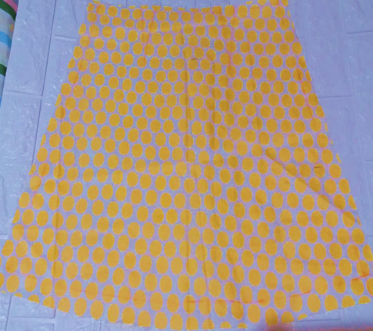 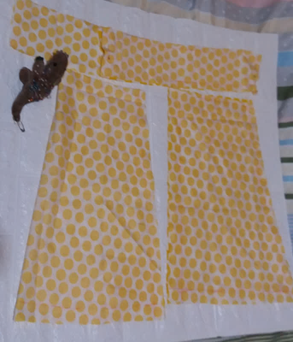

**WAIST BAND**

**FRONT PART BACK PART**

**OPEN FRONT PART**

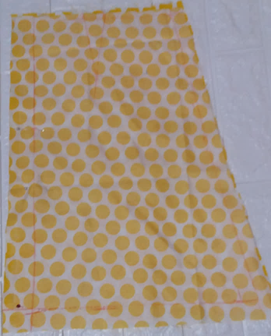

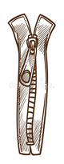

**ZIPPER**

**BACK PART**

# What’s

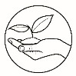

***What’s New***

**ACTIVITY 2**

**SCRAMBLE PROCEDURE:** Rearrange the letters to form a word. Write your

answer in the answer sheet .

1.

|  |  |  |  |  |  |  |
| --- | --- | --- | --- | --- | --- | --- |
| S | M | T | O | H | E | D |
|  |  |  |  |  |  |  |

2.

|  |  |  |  |  |
| --- | --- | --- | --- | --- |
| T | S | I | H | N |
|  |  |  |  |  |

3.

|  |  |  |  |  |  |  |
| --- | --- | --- | --- | --- | --- | --- |
| T | G | U | I | C | T | N |
|  |  |  |  |  |  |  |

4.

|  |  |  |  |  |  |
| --- | --- | --- | --- | --- | --- |
| A | Y | U | T | O | L |
|  |  |  |  |  |  |

5.

|  |  |  |  |  |  |  |
| --- | --- | --- | --- | --- | --- | --- |
| I | K | N | R | A | M | G |
|  |  |  |  |  |  |  |

6.

|  |  |  |  |  |  |  |  |  |  |
| --- | --- | --- | --- | --- | --- | --- | --- | --- | --- |
| D | O | L | T | E | R | F | N | C | E |
|  |  |  |  |  |  |  |  |  |  |

7.

|  |  |  |  |  |  |  |  |
| --- | --- | --- | --- | --- | --- | --- | --- |
| L | A | T | E | A | R | M | I |
|  |  |  |  |  |  |  |  |

8.

|  |  |  |  |  |  |  |
| --- | --- | --- | --- | --- | --- | --- |
| N | A | T | E | P | R | T |
|  |  |  |  |  |  |  |

9.

|  |  |  |  |  |  |  |  |  |
| --- | --- | --- | --- | --- | --- | --- | --- | --- |
| S | O | R | S | E | C | I | W | S |
|  |  |  |  |  |  |  |  |  |

10.

|  |  |  |  |  |  |  |
| --- | --- | --- | --- | --- | --- | --- |
| G | E | L | S | E | V | A |
|  |  |  |  |  |  |  |

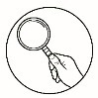

***What Is It***

**What is sewing?**

|  |
| --- |
| **Sewing** is a combination of sewing machine and hand stitches . It used for  the major seams of the garment, while hand stitching are used  primarily for temporary stitches or basting and for finishing the  garment .  **Assembling** is joining cut pieces of fabric together, using basting or by  pinning before machine stitching .  **Sewing Terms:**   1. Stay stitching -used along bias and curved edges to prevent fabric   stretching.  2. Backstitching- is used to secure the ends of a row of stitching .  3. Topstitching - is a row of stitching done on the outside of a garment .  4. Edge stitching - is arow of topstitching very close to the finished  edge.   1. Stitch-in-the-Ditch - a row of stitching done on the outside of a garment in the Groove of a seamline . 2. Hem – is to turn the raw edge under the fold, as the lower edge of a skirt, pants, sleeve and blouses . 3. Placket - a finished opening in a garment made for convenience in   putting on and off the garment .  8. Seam – is joining of two or more pieces of fabric to form a garment .  9. Baste - a temporary stitch made by hand before final sewing is done  10. Seam allowance – a space between the cut edge of the fabric and  the stitching line.  11. Waistband - a band encircling the waistline at the top of a skirt or  pants.  12. Slash - a cut through the centerfold of a dart or curve part .  13. Trim - a cut off ragged edges or part of a seam allowance to rduce  bulk/fold.  14. Fasteners – are made to hold the opening of a garment which ease  in putting on and off.    **Preparing ,assembling and sewing a ladies skirt**  **Assembling and sewing A-line skirt with zipper at back**  1. Prepare the cut pieces of fabric for ladies skirt .  No description available.No description available.2. Pin and baste all the darts front and back of ladies skirt and sew .  3. Prepare the 8 inches long zipper for the back opening . |
|  |

4. Join the center back, leaving 8 inches for zipper attachment then sew.

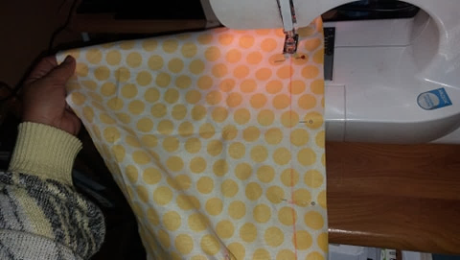

|  |  |
| --- | --- |
| No description available.No description available.No description available.No description available.No description available.5. Prepare zipper and attach to the left side of back part ,atleast ½ “ overlap and 1/16 “ at The right side back part as shown in the illustration .Left over right .  No description available.  6. Join the front and back sides of ladies skirt, then edge stitch. |  |
| No description available.7. Edge stitch the bottom circumference of the ladies skirt .  No description available. |  |
|  |  |
| 8. Prepare the waistband for the ladies skirt, 2 inches center fold width with allwoance and length waist measure plus 3 inches long  No description available.No description available. ( 1 ½” finished waist band ) |  |
|  |  |
|  |  |

9. Attach ½” on one side of the waistband to the waistline of ladies skirt, then sew.

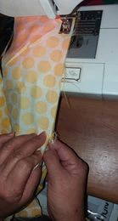

10. Slash the inside seam of the waistband, as illustrated.

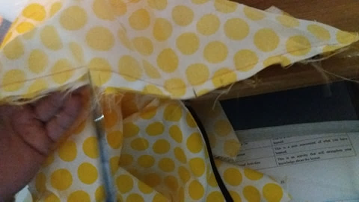

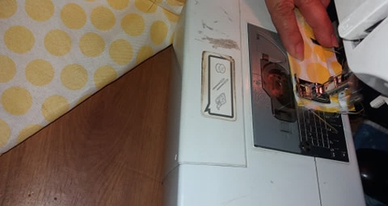11. Close both ends of the waistband ,wrong side together, as illustrated

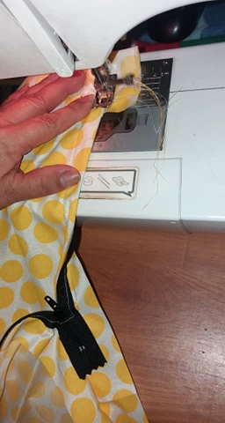

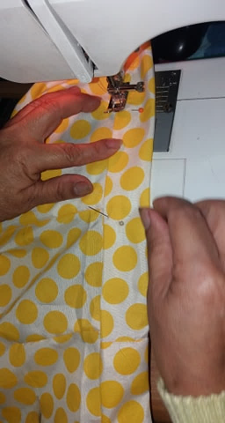12 . Fold inside the ½ “ allowance of the waistband to finish .

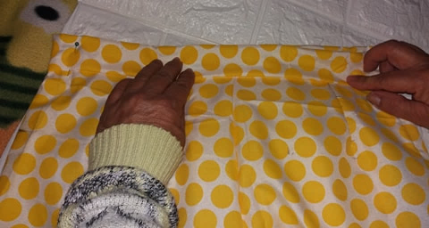

13. Topstitch the fold waistband allowance on the right side of the waist

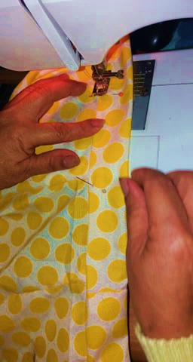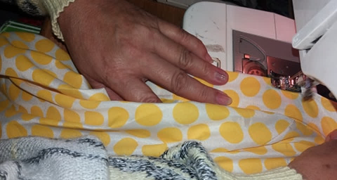 band ,as illustrated.

14. Waistband 1 ½ inch finished .

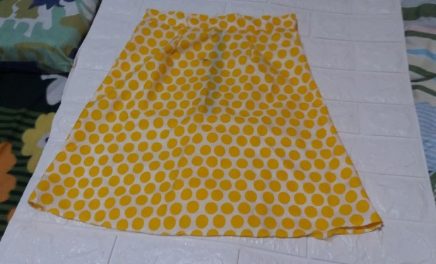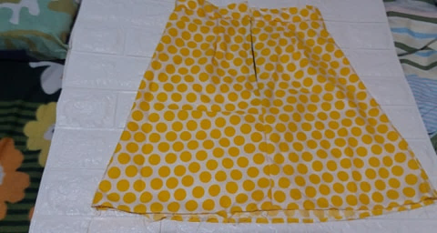

**BACK PART**

**FRONT PART**

**FINISHED - A- LINE SKIRT**

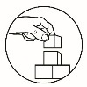

# What’s More

**ACTIVITY 3: True or False :** Write **/** if the statement is correct and write

**X** if the statement is wrong. Write your answer in the answer sheet.

_____1. The hemming is the first step to sew in sewing a ladies skirt.

_____2. Fastener like zipper should be attached before the waistband.

_____3. The finshed zipper of ladies skirt , should be left over right.

_____4. The seam allowonce for ladies skirt is one inch fo plain seam.

_____5. Ladies skirt dart is sewn after the attaching of waistband.

_____6. Machine stitching should always be use in hemming the ladies skirt _____7. Basting is a permanent stitches in a garment.

_____8. Hem is joining of two or more pieces of fabric to form a garment.

_____9. The topstitch is a stitching done outside the garment .

_____10. The zipper is a kind of placket used in putting on and

putting off a garment.

**rections**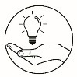

# What I What I Have Learned

**ACTIVITY 4 :** **Word Search** : Pick and combined the needed letters to identify what is the missing word. Write your answer in the answer sheet .

1. A strip of fabric attach to the waistline of a skirt or pant.

W T A B A ________________

I S D N

1. This is a kind of fastener with teeth and slider used in a garment opening .

P P I R __________________

Z E

1. It is a sewing term used in stitching which is done outside the garment .

I G T O S ____________________

C P I N H T

T

4. The temporay stitch by hand before final sewing in the machine is done.

I S T B G

A N ___________________

1. This is a stitching done at the edge of the garment to prevent from raveling the raw edge .

T T E D C H

G E S I ___________________

6.The joining of twor or more pieces of fabric to form a germent is .?

M S A E _________________

7. Is a combination of sewing machine and hand stitches .

S I G E ________________

N W

1. The process of combining cut pieces of fabric together.

G I A S S L N __________________

B E M

1. It is a fold or to turn under a raw edge ,as the lower edge of a skirt, pant ,sleeve and Blouses .

E H M _________________

10. To cut through the centerfold of a dart or curve part to reduce bulk .

H L S A S __________________

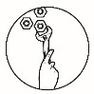

***What I Can Do***

**ACTIVITY 5**

**Sequencing**: Analyze the picture in assembling and sewing ladies skirt,

rearrange the number according its correct steps.

|  |  |
| --- | --- |
|  |  |

|  |
| --- |
| No description available.1. 2. |

|  |
| --- |
| 3. 4. |

|  |
| --- |
| No description available.No description available.5. 6. |

|  |
| --- |
| No description available.No description available.7. 8. |
| No description available.No description available.9. 10 |

|  |
| --- |
| No description available.11. 12. |

|  |
| --- |
| No description available.No description available.13. 14. |



|  |
| --- |
| Correct steps : 15.  a. _______ l. _______  b. _______ m. _______  c. _______ n. _______  e. _______ o. _______  f. _______ p. _______  g. _______  h. _______  i. _______  j. _______  k. ______ |

# C:\Users\DEPED\Desktop\ADM specs\ADM cover and icons\ADM Icons\Tayahin.jpg Post-Assessment

**ACTIVITY 6**

**Directions:** Multiple Choice .Choose the letter of the best

answer.Write the chosen letter in an answer sheet.

_____1. What is the usual length of the zipper use for A-line skirt with zipper

at back?

A. 16 inches long B. 12 inches long

C. 8 inches long D. 3 inches long

_____2. The standard width of a finished waistband for ladies skirt is _____?

A. ½ inch B. ¼ inch

C. 1 ½ inch D. ¾ in

_____3.The position of the finished zipper at the back part of skirt should be

A. Right over left B. Left over right

C. 1/8 inch both side of zipper D. ½ inch both side of zipper

_____4. What is the appropriate stitching used to finish waistband?

A. edge stitching B. Back stitching

C. Topstitching D. Stay stitching

_____5. The first step in assembling and sewing a ladies’ skirt is ____?

A. Sewing B. Assembling

C. Preparing D. Basting

_____6. The part of a ladies skirt which is attached to the waistline.

A. Zipper B. Dart

C. Waistband D. Pocket

_____7. It is a fastener appropriate for ladies skirt placket.

A. Button B. Hook and eye

C. Zipper D. Snap

_____8. It is a combination of machine and hand stitching in garment

construction.

A. Assembling B. Preparing

C. Sewing D. Stitching

_____9. It is to join two pieces of fabric together, by pinning and

basting in assembling garment.

A. Prepare B. Assemble

C. Stitch D. Sew

_____10. This is a temporary stitch made by hand before final sewing is

done.

A. Sew B. Stitch

C. Baste D. Assemble

_____11. This is a strip of fabric encircling the waistline at the top of a skirt

or pants.

A. Placket B. Waistband

C. Fastener D. Seams

_____12. This is the joining of two or more pieces of fabric to form a

garment.

A. Seams B. Slash

C. Hem D. Trim

____ 13. This is a method which is to cut through the center fold of dart,

curve line and center seam.

A. Slash B. Baste

C. Trim D. Cut

____ 14. This is a method which is to cut ragged edges, ravelled thread or

part of seam allowance.

A. Slash B. Baste

C. Trim D. Cut

____15. This is used to provide opening of a garment for ease in putting on

and putting off.

A. Placket B. Waistband

C. Fastener D. Seams

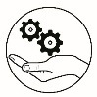

# Additional Activity

**ACTIVITY 7**

**WORD SEARCH**: Search the 15 sewing terms. Write your answer in the answer sheet.

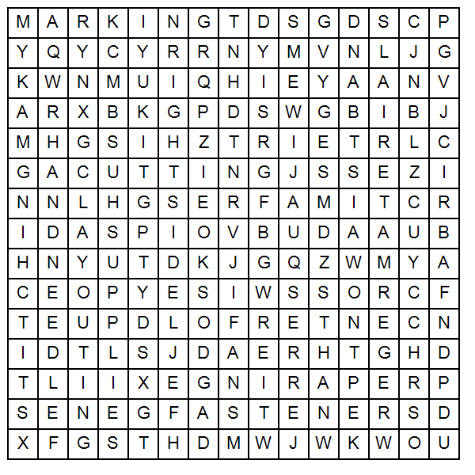

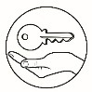

# Answer Key

1.methods

2. hints

3. cutting

4. layout

5. marking

6. center fold

7. material

8. pattern

9. crosswise

10. selvage

1. preparing

2. skirt

3. sewing

4. fabric

5. cutting

6. stitching

7. right side

8. lay-outing

9. marking

10. supplies

11. crosswise

12. center fold

13. thread

14. hand needle

15. fastener

1. X

2. /

3. /

4. /

5. X

6. X

7. X

8. X

9. /

10. /

1.c

2.c

3.a

4.c

5.c

6.c

7.b

8.d

9.b

10.c

11.b

12.b

13.c

14.c

15.c

1.4

2.6

3.5

4.4

5.1

6.2

7.8

8.7

9.10

10.12

11.9

12.14

13.15

14.13

15.11

*1. waisttband*

*2.zipper*

*3.topstitching*

*4.basting*

*5.edgestitching*

*6.seam*

*7.sewing*

*8.assembling*

*9.hem*

*10. slash*

**What I Know** **What’s New**  **What’s More**

**What I Have Learned** **What I Can Do**  **Assessment**

**Additional Activity**

1.c

2.c

3.b

4.b

5.c

6.a

7.a

8.c

9.c

10.b

11.c

12.c

13.a

14.c

15.c

# References

Lewis, Dora. Clothing construction and Wardrobe planning.

New York: McMillan Publishing Company, 1955

Home Technology clothing I and II. Garment Construction

Mississippi Curriculum Framework for Family and Consumer Sciences and Related Technology (Enrichment) (CIP: 20.0101 Comprehensive Consumer & Homemaking. Ed.). Secondary Programs. Distributed by ERIC Clearinghouse, 1995.

Wolfe, Mary Gorgen. *Fashion!* Goodheart-Willcox Company, 2018.

Photos owned by module developer

**For inquiries or feedback, please write or call:**

Department of Education - Bureau of Learning Resources (DepEd-BLR)

Ground Floor, Bonifacio Bldg., DepEd Complex

Meralco Avenue, Pasig City, Philippines 1600

Telefax: (632) 8634-1072; 8634-1054; 8631-4985

Email Address: blr.lrqad@deped.gov.ph * blr.lrpd@deped.gov.ph

Telefax: (632) 8634-1072; 8634-1054; 8631-4985

Email Address: blr.lrqad@deped.gov.ph * blr.lrpd@deped.gov.ph